**Project Title :**

Configuring Exclusive Access to Apple 15 Pro Max in ServiceNow's Service Catalog

**Team Members :**

1.J.Purushothaman

**Gmail:**

1.purushothjp007@gmail.com

**Abstract :**

This configuration establishes restricted access to Apple iPhone 15 Pro Max devices within ServiceNow, ensuring controlled distribution and utilization. The setup includes:

* Catalog visibility restriction to authorized groups
* Quantity limits and approval workflows
* Integrated asset management and inventory tracking
* Priority support SLAs

This configuration enhances device security, streamlines requests, and optimizes asset utilization, providing a tailored experience for authorized users.

**Keywords :** ServiceNow, Exclusive Access, Apple iPhone 15 Pro Max, Catalog Configuration, Asset Management, Security.

**Process :**

**Activity-1 : Create Users :**

* + 1. Open service now.
    2. Click on All >> search for users
    3. Select Users under system security
    4. Click on new
    5. Fill the following details to create a new user

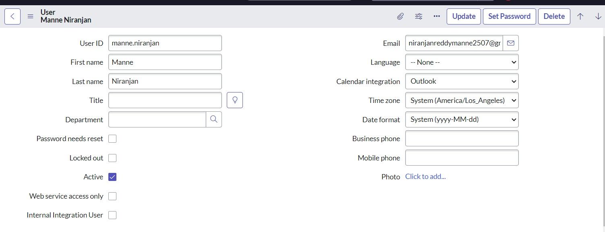

* + 1. Click on submit

**Activity-2 :Create Groups :**

* 1. Open service now.
  2. Click on All >> search for groups
  3. Select groups under system security
  4. Click on new
  5. Fill the following details to create a new group
  6. Name as “ Platform ”
  7. Manger as “ Manne Niranjan ”
  8. Click on save

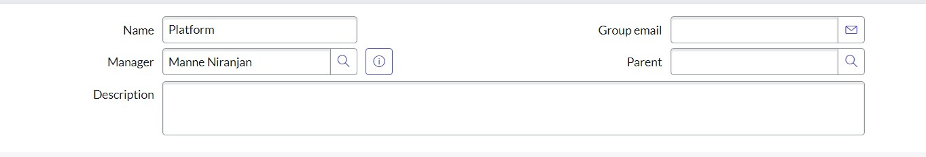

* 1. Go to the Group members Click on Edit, Add Manne Niranjan to platform
  2. Click on save

11

.

Click on Update.

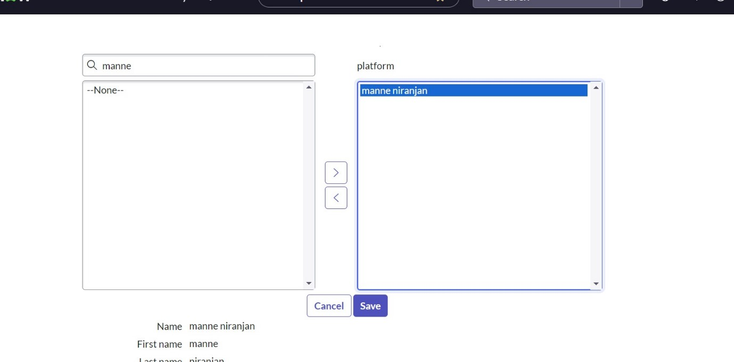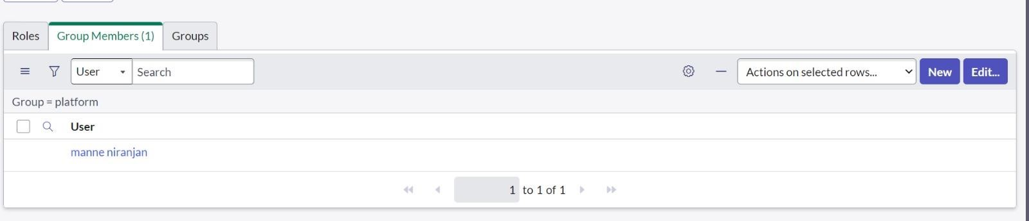

**Activity-3 :Create User Criteria :**

* + 1. Open service now.
    2. Click on All >> search for user Criteria
    3. Select user Criteria under service catalog
    4. Click on New Name: Apple Description :Apple Catalog Enable Whishlist

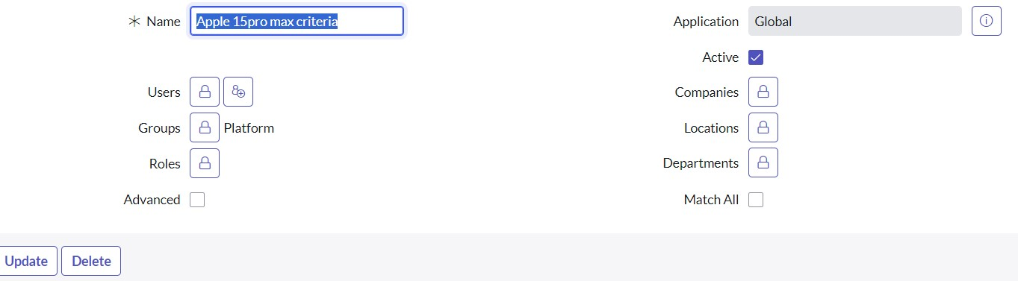

* + 1. .Click on Submit

**Activity-5:Create Categories :**

* + 1. Open service now.
    2. Click on All >> search for maintain Categories
    3. Select maintain Categories under service catalog
    4. Click on newTitle : MobilesCatalog : Apple

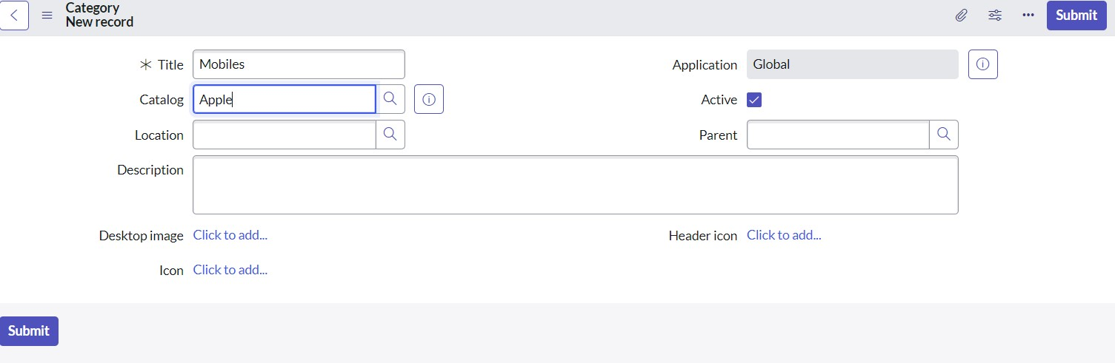

* + 1. Click on Submit

**Activity-6:Create Category Item :**

* + 1. Open service now.
    2. Click on All >> search for maintain items
    3. Select maintain items under service catalog
    4. Click on new Name : Apple 15 pro max Catalogs : Apple Category : Mobiles
    5. Under item details Short description : Apple 15 pro max Description : Hey! The Apple 15 Pro Max is a super cool phone with a big 6.7-inch display, powerful A14 Bionic chip, and amazing camera capabilities. It's got a sleek design and offers a great user experience. It's definitely a top-tier phone!

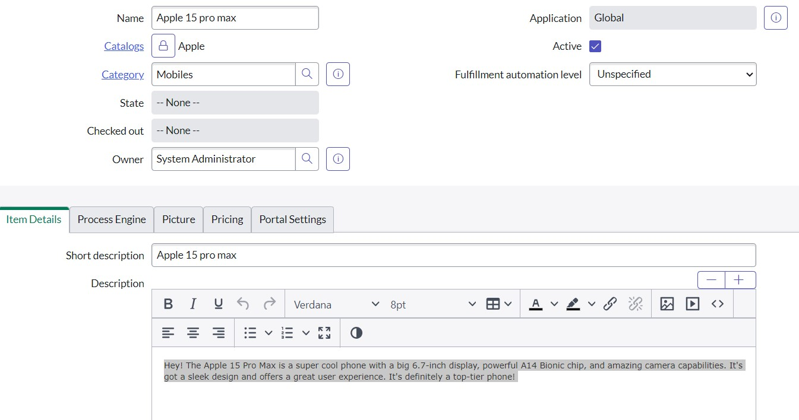

* + 1. Under picture give any image
    2. Under pricing give price details Price : 111 Recurring price : 5 Recurring price frequency : semi annually

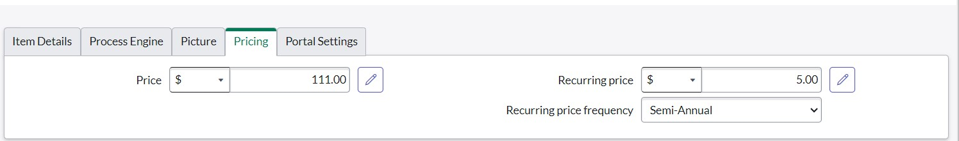

* + 1. Click on save

**Create Variables for for catalog item:**

* 1. Under variables >> click on new

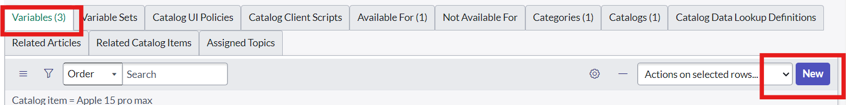

* 1. Give the following information and also mention the order number as 100
  2. click on submit

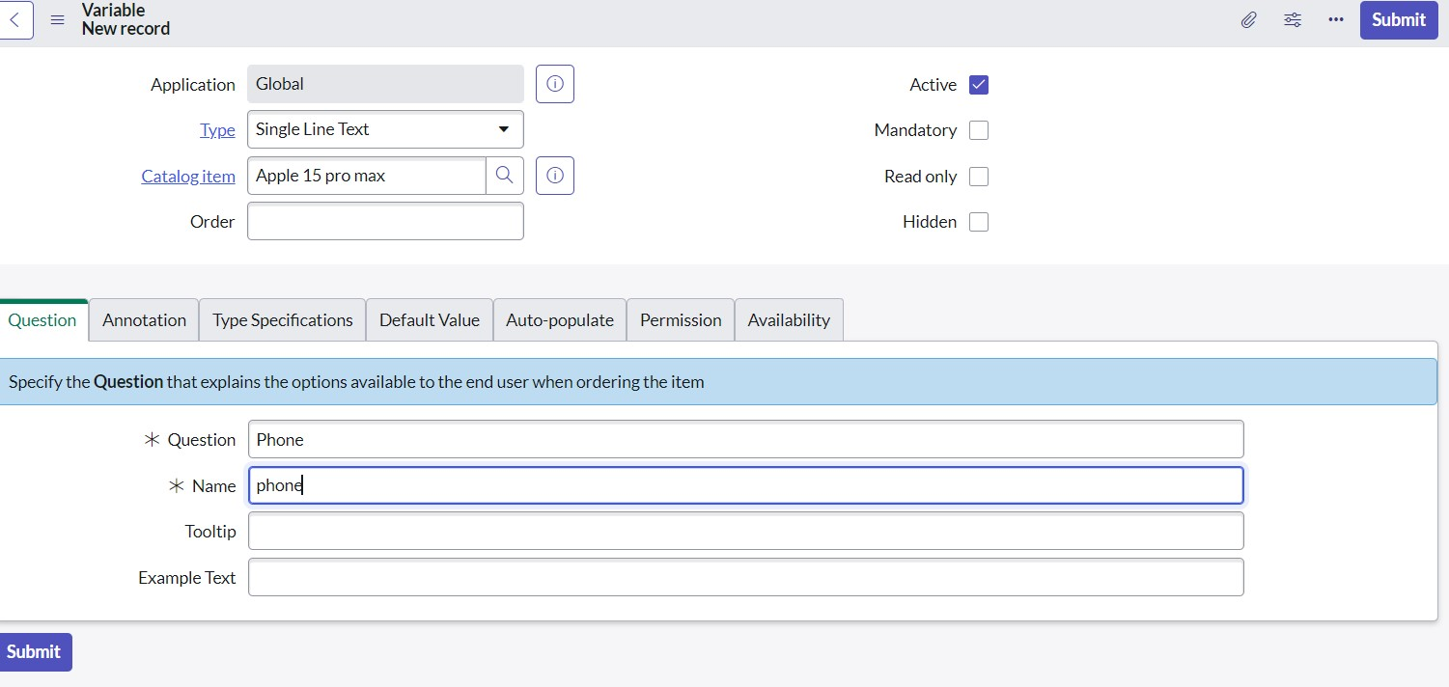

* 1. Create one more variable for name
  2. Also mention the order number as 200

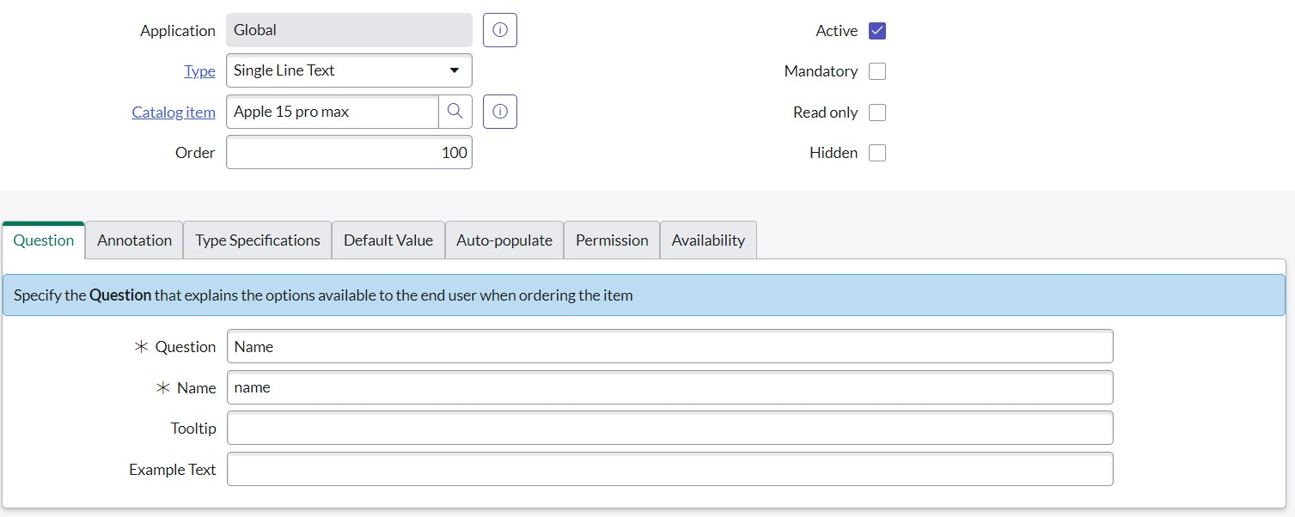

* 1. Create one more variable for email
  2. Also mention the order number as 300

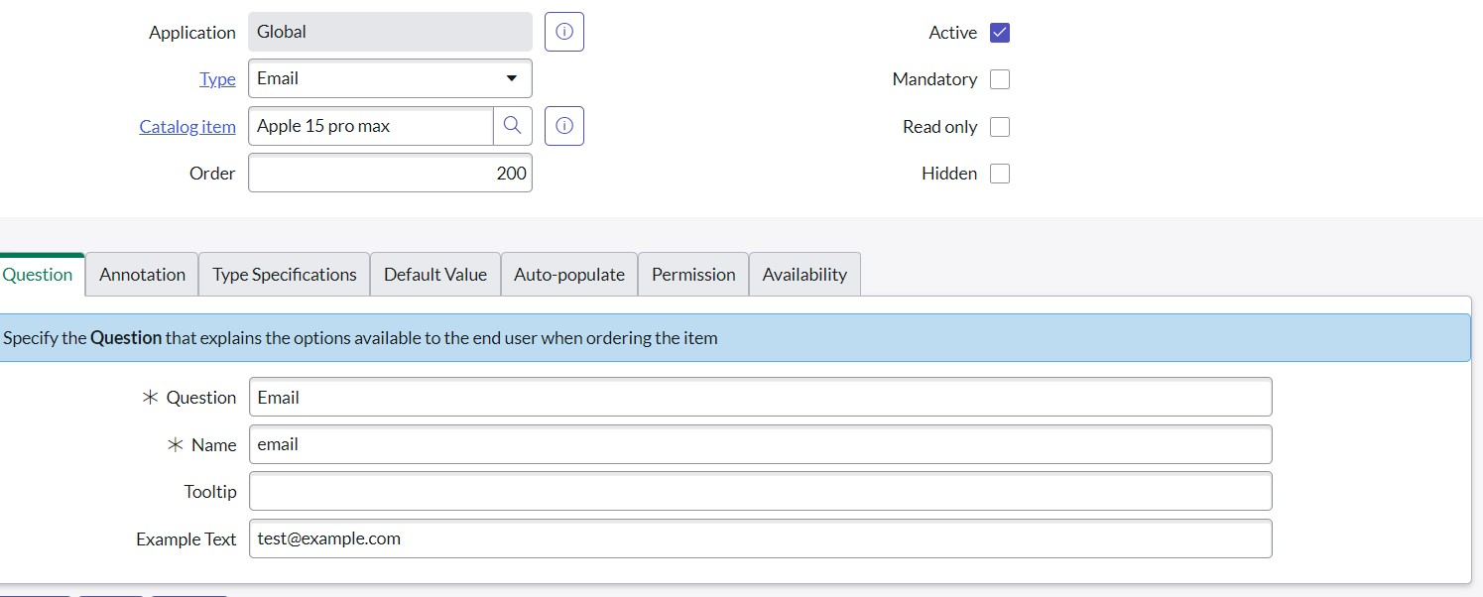

* + 1. Under Available for
    2. Click on edit
    3. Select apple 15 pro max criteria
    4. Click on save

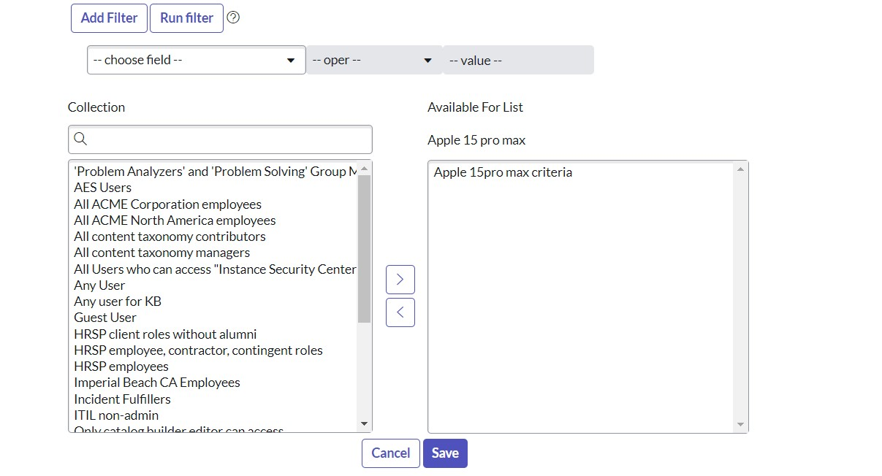

**Activity-7:Assign to portal :**

* 1. Open service now.
  2. Click on All >> search for portal
  3. Select portals under service portal

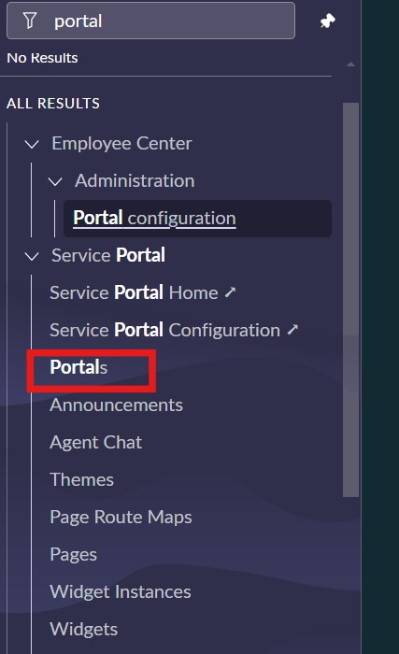

* 1. Then after Select service portal

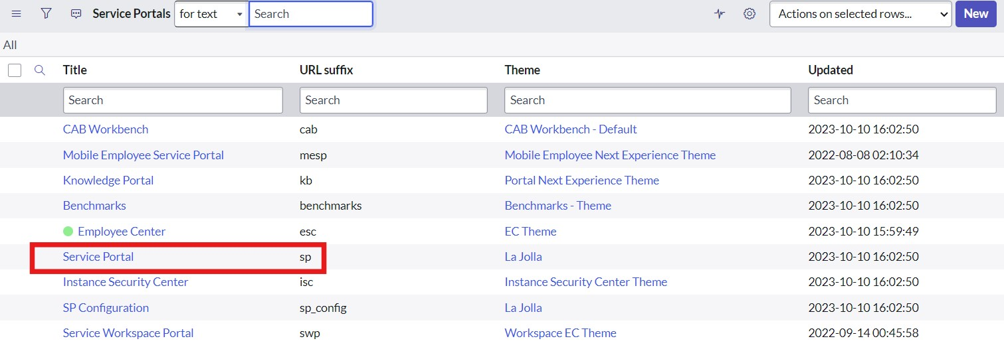

* 1. Scroll down and click on catalogs

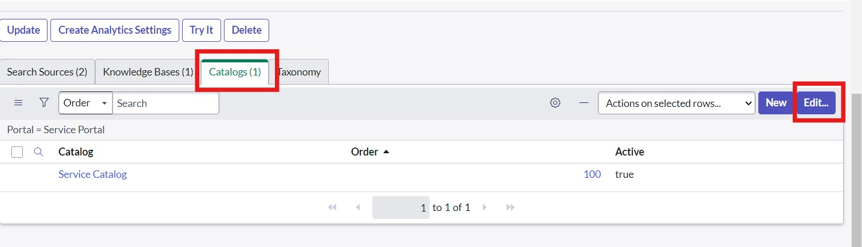

* 1. Click on edit
  2. Move apple to other box and save

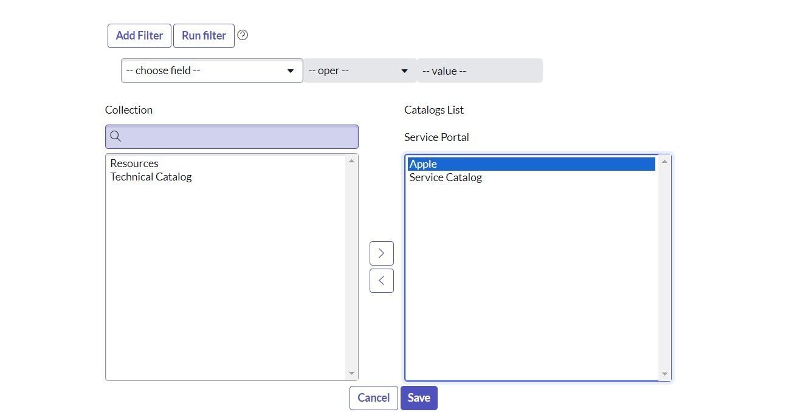

**Conclusion:**

The configuration of exclusive access to Apple iPhone 15 Pro Max in ServiceNow catalog has successfully restricted device access, improved security, and streamlined provisioning processes. Ongoing monitoring and updates will ensure continued effectiveness.